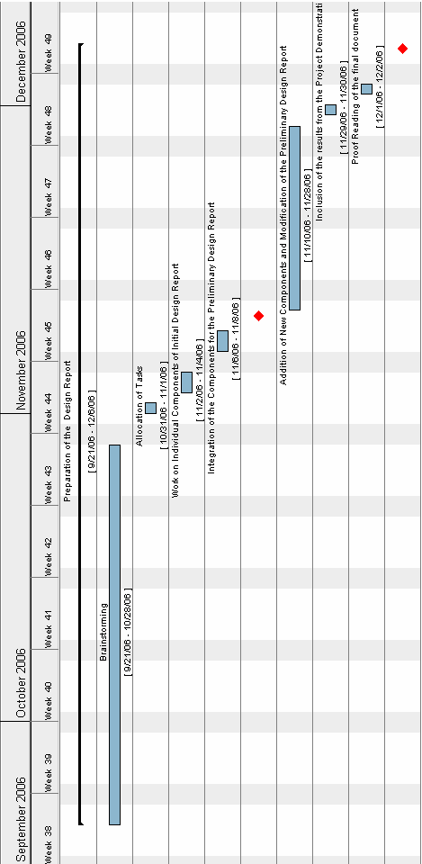

The LEGO® Robot Design Project consists of two tasks namely the design report and the development of software to run the robot.
- As it is evident from the Gantt chart, brainstorming for the design report and its components commenced on September 21st, 2006 which was immediately after the week the project was assigned to us.
- Once the brainstorming finished, tasks were allocated to the respective group members and this was carried out over two days from October 31st to 1st of November.
- The people involved with the design report worked on their assigned components which were later integrated and handed in on November 5th, 2006.
- Once the initial design report was handed in, the team members continued to work from 10th November to the 28th and added new components to the final design report as well as fixing the initial report.
- The results from the robot demonstration were added to the report during the period from 29th November to the 30th.
The report was proof read and was ready to be handed in on the 5th of December, 2006.

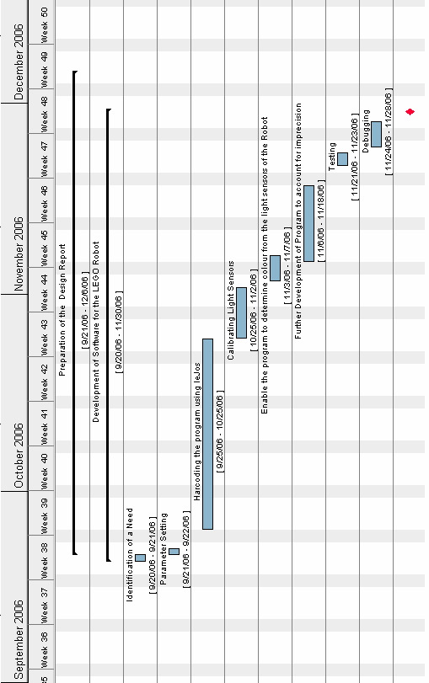
The second component of the design project involved programming a LEGO robot. The design environment used was leJos®.
- The first step was identifying the need and hence the means to develop a robot.
- The parameters for the robot were set during the period between 21st September and 22nd September.
- The program to run the robot and turn according to the colors detected by the sensors was hard coded during 25th September and 25th October.
- The light sensors were calibrated during the time provided in the Software Engineering 101 lab sessions. This took place between 25th October and 7th November.
- The program was further developed and minor inaccuracies were accounted for during the period between 6th November and 18th November.
- The testing of the program was done from the 21st November to the 28th.

The robot was made to go across a course on the 29th of September and this day marked the end of the programming process.

